English

Read Write Inc
Spelling &Grammar
Comprehension skills
Writing for a variety of purposes
Maths
Addition/Subtraction
Place Value
Decimals and Fractions
Multiplication and Division
Shape
Real-lifeMaths
Science
Plants
Animals Including Humans

Computing
Computer skills
Simple coding

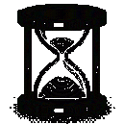

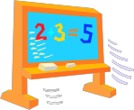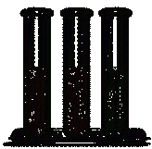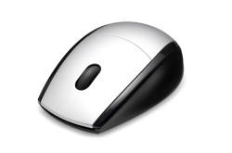History

All change? Holidays now and then

Year 2

Summer Term

Geography

Holidays – where shall we go?
Place comparisons – geographical features

Music
Charanga

P.E
Striking and Fielding Games

Art
Observational Drawing and Collage
R.E
How do Buddhists show their Beliefs?
PSHCE
Healthy Bodies, Healthy Minds
(Good to be me)
Ready, Steady, Go
(Changes)

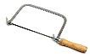

D.T.
make a lighthouse
KeyTexts
Flat Stanley
The Lighthouse Keeper

EndProduct
Designing and Planning your perfect Holiday

