English

Reading a wide range of texts
and using explicit reading skills: retrieval, vocabulary, inference, prediction, summary and comment.
Reading AR books and completing quizzes.
Writing in a wide range of narrative and non-narrative styles
Oxford Owl spelling
Handwriting practice
Grammar and punctuation practice

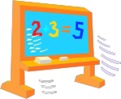

Maths
Number and Place Value
Addition/ Subtraction Multiplication and Division
Decimals and Fractions
Geometry - shape and position
Data and graphs
Real-life Maths
Investigations
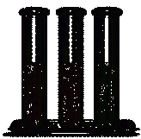
Science
Living Things and Habitats
Study of the local environment
Recognising environmental change

Sound

Working scientifically

Computing
E-Safety/ Safer Internet
Digital Literacy and using a wide range of software
Control

History

A Study of Langley Park and its mining heritage

Year 4

Summer Term

Geography
Local fieldwork

Music
Blackbird
Reflect, Rewind, Replay

P.E
Striking/ fielding games-zone cricket
Athletics

Art
Drawing and painting-
Observational drawing of artefacts and outdoors
Pitmen painters
R.E
What do Christians believe about God?
PSHCE
Healthy Body, healthy Mind
Changes

Our Trip
Ministeracres

French
The Body
Sport
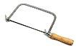
D.T.
Cooking and nutrition- Eating what we grow

